1. Design
   1. Interface
   2. Terrain (concept/sketch) -
2. API (Obj. list / Scripts)
   1. 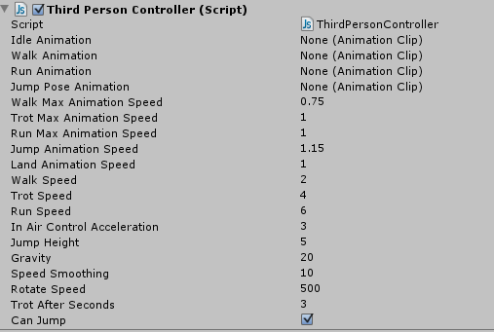Input/output
   2. Description
   3. Chronological/Map scripts